**SMART STAR EXAMINATIONS BOARD**

**END OF TERM I EXAMINATIONS - 2024**



**READING**

**PRIMARY TWO**

***Time Allowed: 2*** *hours*

**Name...........................................................Stream............**

**INSTRUCTIONS**

1. ***Avoid unnecessary crossing of work.***
2. ***Use very good handwriting.***

**1. Join the syllables and sounds to form correct words.**

sm-a-l-l __________ b-oo-k __________

sch-oo-l __________ s-oa-p __________

1. **Make sentences using the given words.**
2. **teacher: _____________________________________**
3. **washing:**

**_____________________________________**

1. **Read and draw.**
2. She is reading a book
3. Mummy is cooking food
4. **Circle words with the given sound.**

ed: bread, bed, bad, badge

th: mat, eight, both, bench

ng: girl, garage, hand, king

qu: quiet, water, land, school

1. **Read the sounds and words to your teacher (oral).**

ee - bleed ai - sail

oo - groom ng – ring

oa – foal th– growth

1. **Choose the right word from those in brackets to fill the spaces.**
2. That is _______new home. (their, there)
3. We should ____________in order to

be forgiven. (pray, play)

1. This is the place_____________we

learn from. (where, were)

1. That is her____________ (sun, son)
2. 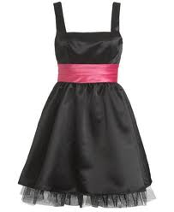**Add one or two letters before the word and write the name of the picture.**

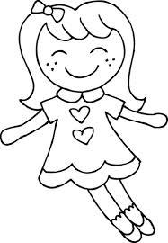 **Oll ess**

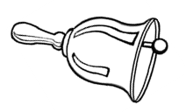 **ell ble**

1. **Make correct sentences.**

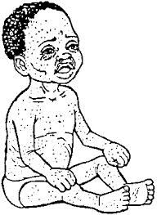

 **______________________________**

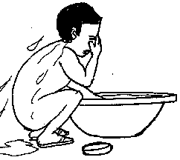

**______________________________**

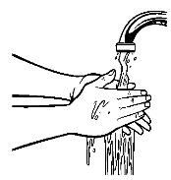

1. **Form words.**

an

ha

ta

sta

i) ___________________

r

t

p

ii) ___________________

iii) ___________________

1. **Read the dialogue and answer questions about it in full sentences.**

Daizy : Good morning Joline.

Joline :Good morning Daizy

Daizy : What are you going to do now?

Joline :Am going to bathe.

Daizy : Ooh, why do you bathe?

Joline :I bathe to remove dirt.

Daizy : What do you use to bathe?

Joline :I use soap, water and sponge.

Daizy : Okay, go and bathe

**Questions:**

1. Write the two people in the dialogue.
2. _______________ ii) _______________

b) Where is Joline going?

_______________________________________

1. Why is Joline bathing?

_______________________________________

1. Give two words with sound “ng” from

the dialogue

1. _______________ ii) _______________
2. List two things she uses to bathe
3. ______________ ii) ________________
4. Draw Joline bathing
5. **Fill in the words with “oa” sound to complete the sentences correctly.**
6. The __________is sailing on water.
7. She is walking along the ___________.
8. The ______________ is eating grass.
9. Emma is wearing a ______________.
10. **Read a tongue twister and answer the questions.**

Man made money but

money made man mad.

**By Doreen**.

**Questions:**

1. Who made money?

______________________________________

1. What made man mad?

______________________________________

1. Who wrote the tongue twister?

______________________________________

1. Write two words with syllable “ma”

from thetongue twister.

1. ___________________
2. ___________________

**END.**